This is what you do to get a copy of it to post it.

From AR or AP, go to Batch Inquiry.

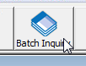

Find the error batch, click once on it so it’s highlighted in blue and select recover.

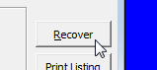

Click OK with selections as per below, it might force you to change the doc number but you can then fix it in the open batch

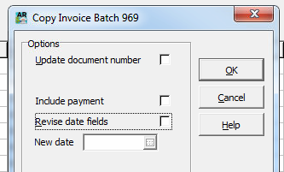

Got Invoices

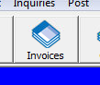

Post the batch.